D207 Performance Assessment
DATA CLEANING
Instructor: Dr. William Sewell
Student name: Devon E. Johnson
Student ID: 011494484
Email: djo3593@wgu.edu

A1. Research Question
In an effort to build on my last performance assessment in D206, I will now narrow my research question to investigate specific potential variables behind patient readmission.
Research Question: "Are overweight patients more likely to be readmitted?"
A2. Benefits of Research Question
Medical infrastructure is often over-taxed by too many patients and too few doctors to provide quality and timely care. Addressing potential factors that contribute to patient re-admittance could result in a reduction or easier distribution of overall patient numbers, thus reducing this load. If patients above a certain BMI are assessed to be more at risk of readmittance, then doctors/clinics might consider incorporating more treatments designed to return patients to health body weights, e.g. nutritionist referrals, physical therapy, medications, etc. in conjunction with the treatment for whatever present ailment is diagnosed.
A3. Relevant Data Identification
The relevant variables for this research question are:
  - readmis_within_month (Example: No)
    - Data Dictionary Description: Whether the patient was readmitted within a month of release or not: yes, no
    - Variable Type: Categorical/Nominal
    - Datatype Property: object
  - overweight (Example: 1)
    - Data Dictionary Description: Whether the patient is considered overweight based on age, gender, and height: yes, no
    - Variable Type: Categorical/Nominal
    - Datatype Property: float64
B1. Statistical Analysis
```python
import pandas as pd
file_path = r'C:\Users\My Name Devon\OneDrive\Documents\WGU MSDA\D207\medical_clean.csv'
df = pd.read_csv(file_path, index_col = 0)
df.info(memory_usage="deep")
```

<class 'pandas.core.frame.DataFrame'>
Index: 10000 entries, 1 to 10000
Data columns (total 49 columns):
# Column Non-Null Count Dtype
--- ------ -------------- -----
0 Customer_id 10000 non-null object
1 Interaction 10000 non-null object
2 UID 10000 non-null object
3 City 10000 non-null object
4 State 10000 non-null object
5 County 10000 non-null object
6 Zip 10000 non-null int64
7 Lat 10000 non-null float64
8 Lng 10000 non-null float64
9 Population 10000 non-null int64
10 Area 10000 non-null object
11 TimeZone 10000 non-null object
12 Job 10000 non-null object
13 Children 10000 non-null int64
14 Age 10000 non-null int64
15 Income 10000 non-null float64
16 Marital 10000 non-null object
17 Gender 10000 non-null object
18 ReAdmis 10000 non-null object
19 VitD_levels 10000 non-null float64
20 Doc_visits 10000 non-null int64
21 Full_meals_eaten 10000 non-null int64
22 vitD_supp 10000 non-null int64
23 Soft_drink 10000 non-null object
24 Initial_admin 10000 non-null object
25 HighBlood 10000 non-null object
26 Stroke 10000 non-null object
27 Complication_risk 10000 non-null object
28 Overweight 10000 non-null object
29 Arthritis 10000 non-null object
30 Diabetes 10000 non-null object
31 Hyperlipidemia 10000 non-null object
32 BackPain 10000 non-null object
33 Anxiety 10000 non-null object
34 Allergic_rhinitis 10000 non-null object
35 Reflux_esophagitis 10000 non-null object
36 Asthma 10000 non-null object
37 Services 10000 non-null object
38 Initial_days 10000 non-null float64
39 TotalCharge 10000 non-null float64
40 Additional_charges 10000 non-null float64
41 Item1 10000 non-null int64
42 Item2 10000 non-null int64
43 Item3 10000 non-null int64
44 Item4 10000 non-null int64
45 Item5 10000 non-null int64
46 Item6 10000 non-null int64
47 Item7 10000 non-null int64
48 Item8 10000 non-null int64
dtypes: float64(7), int64(15), object(27)
memory usage: 18.5 MB

## B1: Statistical Analysis

from scipy import stats
from scipy.stats import chi2
crosstab = pd.crosstab(df['Overweight'], df['ReAdmis'])
stats.chi2_contingency(crosstab)
Chi2ContingencyResult(statistic=0.6984802059617876, pvalue=0.4032948387365496, dof=1, expected_freq=array([[1839.7886, 1066.2114],
[4491.2114, 2602.7886]]))

B2. Outcome of Statistical Analysis
statistic=0.6984802059617876: This demonstrates the difference in the observed frequencies between two categories and the expected frequencies that would indicate the variables were statistically independent (The University of Utah, n.d.).
p-value=0.4032948387365496: The p-value, or probability value, quantifies the probability that the null hypothesis is true. The larger the p-value, the more likely that the null hypothesis cannot be rejected. Typically, p-values are compared to a significance level of 0.05 – if the p-value is less than 0.05 it is deemed significant, and if it is larger then it is deemed insignificant (Kwak, 2023).
dof=1: DoF, or degrees of freedom, is the number of independent numbers in the data sample. A higher value for DoF indicates a larger sample size which means there is more power to find a statistically significant result. Transversely, a lower DoF would indicate a data sample with a high number of outliers which would make it more difficult to reject the null hypothesis conclusively (Turney, 2023).
expected_freq=array([[1839.7886, 1066.2114]]): This is the expected frequency if the tested variables were statistically independent, to which the observed frequencies are compared (The University of Utah, n.d.).
B3. Justification
As I chose two categorical variables to evaluate, I implemented the Chi Square of Independence test. This is the standard when one is analyzing a potential relationship between two categorical variables (UCLA, n.d.). The Chi Square test may be used with both ordinal and nominal data, but is best suited to nominal data, which works in this case as both the variables tested are nominal (McHugh, 2013).
C. Univariate Analysis
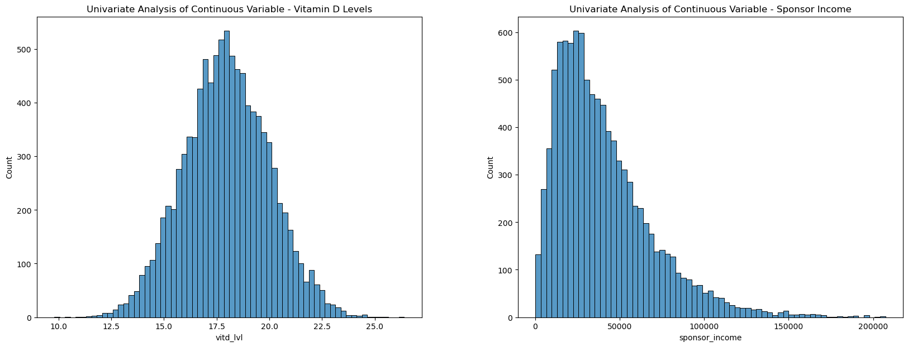
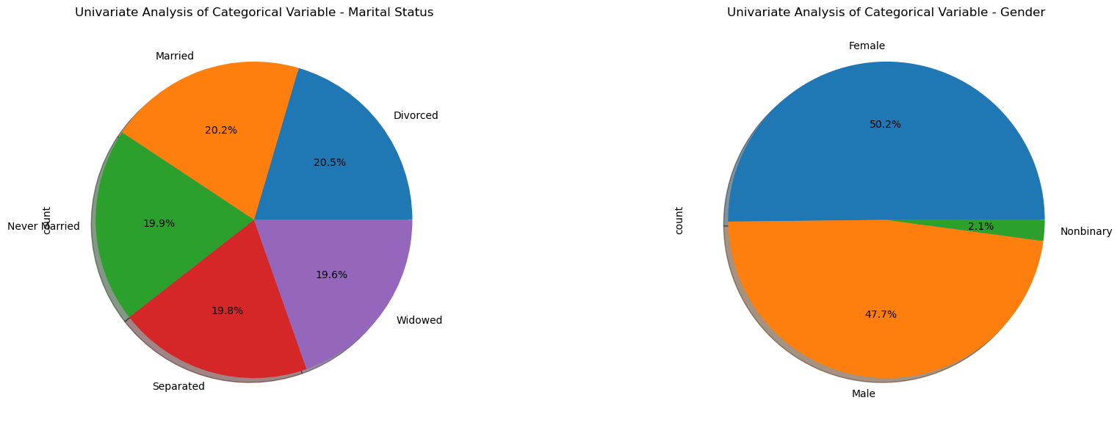
I generated two histograms to display the univariate analysis of my continuous variables, “vitd_lvl” and “sponsor_income.” The x-axis in these charts represents the class interval while the y-axis shows the corresponding frequency for each of those intervals.
The first histogram displaying the distribution of vitamin D levels shows a fairly normal distribution, indicating that the data is evenly distributed across the sample and there aren’t too many outliers. The median, mode, and mean are all centered in this sample. The second histogram showing the distribution of income is strongly right, or positively, skewed, showing that more data points are concentrated on the left side and indicating that the mean is greater than the median and mode ("How to interpret histograms," 2024).
For my univariate analysis of my categorical variables, “marital_status” and “gender,” I opted to use pie charts. These show how the categories are proportioned in each data sample. The first pie chart displaying the distribution across “marital_status” show that there are fairly even representations from each category, “Married,” “Divorced,” “Widowed,” “Separated,” and “Never Married.” In contrast, the pie chart for gender shows that male and female participants are more or less equally represented, with slightly less males than females, but there are very few non-binary entries ("12 univariate data visualizations with illustrations in Python," 2024).
D. Bivariate Analysis
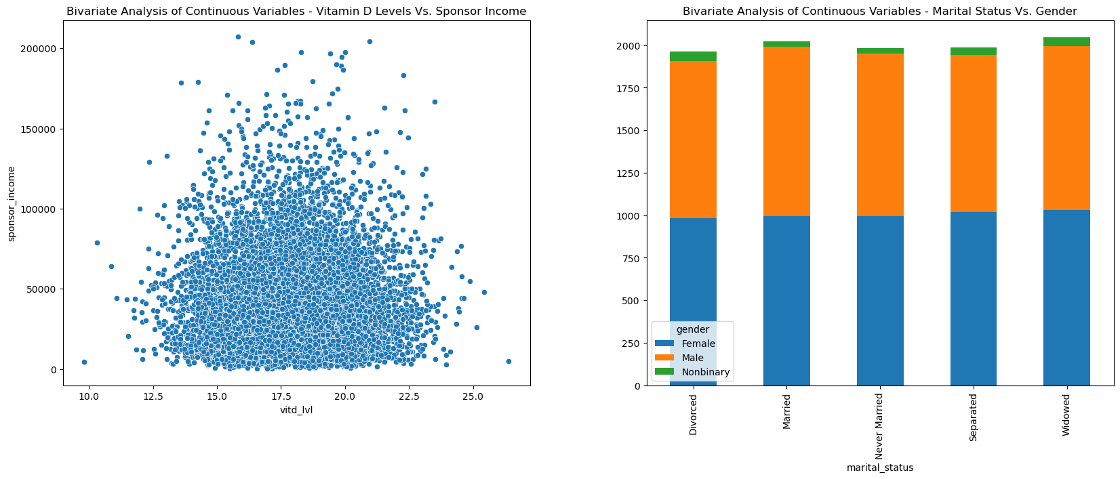
I again used my variables from my univariate analysis but now compared them to each other in a bivariate analysis using appropriate visualizations.
For my continuous variables, vitamin D levels and sponsor income, I generate a scatter plot to display how sponsor income varies across different patients with different vitamin D levels. The data was fairly concentrated, showing that most patients had an average income between about $10,000 and $80,000 and also had vitamin D levels between 15.0 and 22.5. Patients with higher income seemed more likely to have vitamin D levels within the median range, while patients with lower incomes seemed slightly more likely to spread to the lower or upper ends of the spectrum.
For my categorical variables, marital status and gender, I plotted a stacked bar chart using a crosstab of those two variables. The resulting chart showed that there was, again, a fairly equal distribution of males and females across each marital status category. Men were slightly less likely to be divorced, never married, or separated than women, though one must remember that men also comprised less of the overall data sample than women. As non-binary patients comprised little of the data sample to begin with, they only appeared in the fringes of each marital status category but were nonetheless represented in all five (Donatello & Roualdes, 2023).
E1. Results of Hypothesis Test
The chi-square test conducted to test a relationship between readmission and patients who were overweight failed to reject the null hypothesis. In other words, the test did not reveal a statistically significant indication that patients were more or less likely to be admitted if they were overweight. The DoF value of 1 showed that we had enough“freedom”or independent numbers in the data sample to proceed with the test, so we can relatively trust the results of this analysis. The p-value was far above the common standard of 0.05 for significance or alpha level, indicating a low probability of a statistically significant relationship. Correspondingly, the chi-square value came in at about 0.70, rounded up from two decimal points which is far below 3.841, the indicated critical value, as determined by our values for degrees of freedom and significance level. The observed frequencies were relatively close to the expected frequencies under the assumption of independence ("The chi-square test for independence," n.d.).
Table showing the corresponding chi-square critical values for different p-values and degrees of freedom.
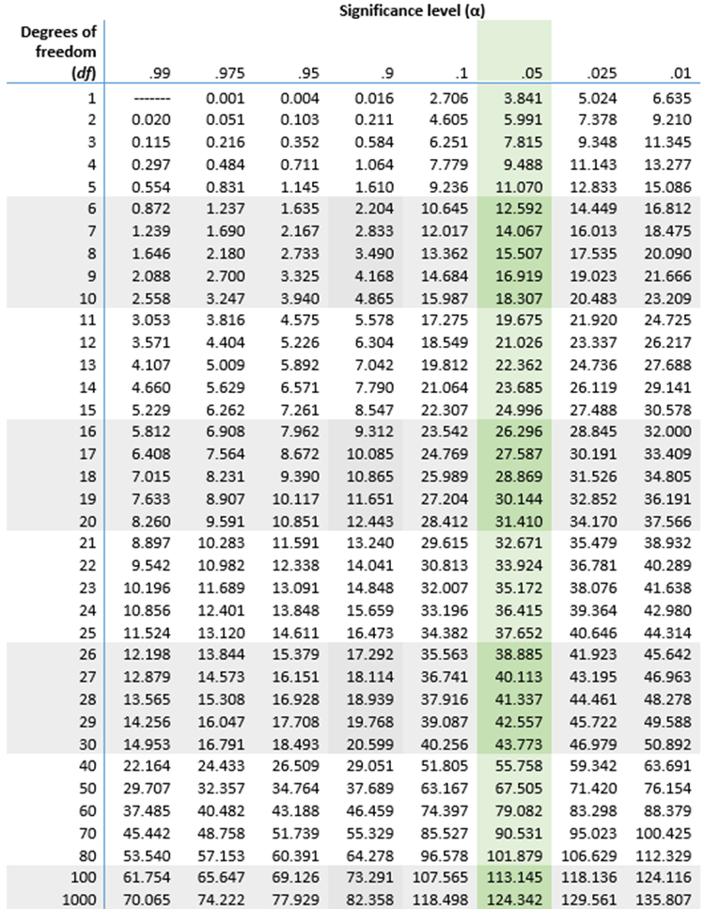
Note. Turney, S. (Publisher). (2022). Chi-square distribution table (right-tail probabilities). [Table]. https://www.scribbr.com/statistics/chi-square-distribution-table
E2. Limitations of Data Analysis
Although we had enough degrees of freedom to conduct the chi-square test, we are still operating with a relatively small data sample which is represented by the relatively low value for degrees of freedom. A large sample size with randomly selected patients would lend more credence to the data analysis and end result (Hayes, 2024).

E3. Recommended Course of Action
A larger data sample would help to more conclusively establish a lack of relationship between overweight patients and readmission. Additionally, it would likely be beneficial to consider other potential confounding variables such as gender or sponsor income, as these factors may also affect the relationship. For example, overweight men might be more likely to be readmitted than overweight women, but because they represent a smaller subsection of the data sample it might not appear in our end data analysis.
F. Panopto Recording
The Panopto explanation of my code may be found at the following link: https://wgu.hosted.panopto.com/Panopto/Pages/Viewer.aspx?id=3190346d-7f43-4cbb-a873-b265007fffd3
G. Code References
Chi2_contingency -SciPy v1.14.1 manual. (n.d.). The SciPy Community. https://docs.scipy.org/doc/scipy/reference/generated/scipy.stats.chi2_contingency.html
How to create multiple subplots in Matplotlib in Python? (2024, January 16). GeeksforGeeks. https://www.geeksforgeeks.org/how-to-create-multiple-subplots-in-matplotlib-in-python/
How to plot value counts in pandas. (2024, July 22). GeeksforGeeks. https://www.geeksforgeeks.org/how-to-plot-value-counts-in-pandas/
Seaborn.histplot-Seaborn 0.13.2 documentation. (n.d.). seaborn. https://seaborn.pydata.org/generated/seaborn.histplot.html
Seaborn.scatterplot- Seaborn 0.13.2 documentation. (n.d.). seaborn. https://seaborn.pydata.org/generated/seaborn.scatterplot.html
Stacked bar chart- Matplotlib 3.10.0 documentation. (n.d.). Matplotlib. https://matplotlib.org/stable/gallery/lines_bars_and_markers/bar_stacked.html
H. Source References
12 univariate data visualizations with illustrations in Python. (2024, December 9). Analytics Vidhya. https://www.analyticsvidhya.com/blog/2020/07/univariate-analysis-visualization-with-illustrations-in-python/
The chi-square test for independence. (n.d.). Department of Sociology - The University of Utah. https://soc.utah.edu/sociology3112/chi-square.php
Donatello, R., & Roualdes, E. (2023, August 5). 2.4 bivariate visualizations. norcalbiostat.com. https://norcalbiostat.github.io/AppliedStatistics_notes/bivariate-visualizations.html
Hayes, A. (2024, July 30). CHI-square (χ2) statistic: What it is, examples, how and when to use the test. Investopedia. https://www.investopedia.com/terms/c/chi-square-statistic.asp
How to interpret histograms. (2024, August 16). LabXchange. https://www.labxchange.org/library/items/lb:LabXchange:10d3270e:html:1
Kwak, S. (2023). Are only p-values less than 0.05 significant? A <i>p</i>-value greater than 0.05 is also significant! Journal of Lipid and Atherosclerosis, 12(2), 89. https://doi.org/10.12997/jla.2023.12.2.89
McHugh, M. L. (2013). The Chi-square test of independence. Biochemia Medica, 23(2), 143-149. https://pmc.ncbi.nlm.nih.gov/articles/PMC3900058/
Turney, S. (2023, July 7). How to find degrees of freedom | Definition & formula. Scribbr. https://www.scribbr.com/statistics/degrees-of-freedom/
Turney, S. (2023, June 21). Chi-square distribution table (right-tail probabilities) [Table]. Scribbr. https://www.scribbr.com/statistics/chi-square-distribution-table/
UCLA. (n.d.). What statistical analysis should I use? Statistical analyses using SPSS. OARC Stats – Statistical Consulting Web Resources. https://stats.oarc.ucla.edu/spss/whatstat/what-statistical-analysis-should-i-usestatistical-analyses-using-spss/#:~:text=A%20chi%2Dsquare%20test%20is,relationship%20between%20two%20categorical%20variables
The University of Utah. (n.d.). The chi-square test for independence. Department of Sociology - The University of Utah. https://soc.utah.edu/sociology3112/chi-square.php

